Point-of-Sale Malware Techniques and Abusing an Insecure Thermal Printer

Micah Flack  
*Beacom College of Computing and Cyber Sciences  
Dakota State University*Madison, South Dakota, USA  
micah.flack@trojans.dsu.edu  
  
Dr. Meikang Qiu  
*Beacom College of Computing and Cyber Sciences  
Dakota State University*Madison, South Dakota, USA  
meikang.qiu@dsu.edu

*Abstract*— This paper discusses the potential security vulnerabilities in point-of-sale (POS) systems that are often overlooked, such as internal and external accessories like scanners and printers. The paper provides a literature review of common POS malware techniques, including memory scraping, EMV skimming, and NFC sniffing. The paper also discusses the use of serial debug ports in these devices and how they can be accessed and exploited by attackers. The paper concludes with a technical analysis of a common thermal printer and ways in which it could be exploited.

Keywords—joint test action group, jtag, point-of-sale, POS, hardware hacking, serial debug port

# Introduction

Retail businesses have become increasingly reliant on digital transactions since the creation of the point-of-sale (POS) system by IBM in 1973. Which, criminals were quick to notice and have since been targeting those systems for their customer data. For instance, the 19 months between February 2021 and September 2022, there were 167,000 stolen payment records because of two POS malware operators using existing RAM scraping malware [1].

However, an often-overlooked area to compromise POS systems is the internal or external accessories needed to scan items or print receipts. Usually, they are connected directly to the system over any available USB port and do not implement bootloader security measures to limit the device addresses to specific USB ports. They also have enough processing power to run a lightweight webserver, or from a malicious perspective, as cloned human input devices (HID) on top of their original function.

In this paper we discuss the different types of serial debug ports used, how to access them, as well as expected security implementations. A literature review is provided for current research into POS malware techniques and how they could have been avoided. We conclude with a technical analysis of a common thermal printer and ways an attacker could exploit misconfiguration of the serial debug port.

# Literature Review

There are several common POS malware techniques that are used to steal payment records. Some of the most common techniques are summarized in the following research papers:

## Memory Scraping

Memory, or random access memory (RAM), scraping is a type of cyber-attack that involves extracting sensitive data from the RAM of a point-of-sale (POS) system. This type of attack is often performed by installing malware on the POS system, which allows the attacker to access the system's memory and extract sensitive data such as payment card information. This data is then typically exfiltrated, or transferred, to the attacker's server, where it can be used for fraudulent purposes.

To perform a RAM scraping attack, the attacker first needs to gain access to the POS system. This can be done through various methods, such as using a USB drive to install malware on the system, or by remotely accessing the system through a network vulnerability. Once the malware is installed, it can then be used to access the system's memory and extract sensitive data from it.

Overall, RAM scraping is a serious threat to the security of POS systems, as it allows attackers to access and exfiltrate sensitive data from the system's memory. This type of attack can be difficult to detect and prevent, which makes it important for organizations to implement robust security measures to protect their POS systems and the sensitive data they contain [2].

## EMV Skimming

The EMV protocol, which is used for debit and credit card payments worldwide, is vulnerable to "pre-play" attacks that can be used to steal payment card information and make fraudulent purchases. These attacks work by collecting authentication data from a card at one moment in time and then using it to make transactions at a later time that has been predetermined when the data was harvested. This is possible due to a specification flaw in the EMV protocol that does not include the identity of the terminal, and a deeper protocol design flaw that allows a man-in-the-middle device between the terminal and the bank to be used to attack a system where the random number generation is sound.

These vulnerabilities in the EMV protocol are significant because they can be exploited without requiring a significant level of technical expertise, and they can be difficult to detect. This means that criminals can use pre-play attacks to steal payment card information and make fraudulent purchases without being detected. Businesses and customers should be aware of these vulnerabilities and take steps to protect themselves from pre-play attacks, such as using encryption and regular security audits [3].

## NFC Sniffing

Near Field Communication (NFC) is a contactless communication technology used for data communication between two NFC devices placed at a short distance. The use of NFC applications and devices often requires the processing of important and sensitive user data that can be misused by malicious parties. By analyzing the payment application based on NFC technology, authors demonstrate that an attacker can remotely steal, without the knowledge of the client, the banking data stored in an bank card or an NFC equipped smartphone. In this paper, we are interested in discussing the security of NFC banking transactions by presenting the most known attacks and the main solutions proposed to face these attacks.

They first present the known attacks on NFC devices and communications during banking transactions, such as relay attack, Denial of Service (DoS), and Man in The Middle (MiTM) attacks. In the next section, they discuss the advantages and limitations of the main solutions proposed to secure NFC banking transactions, including the use of encryption, authentication, and secure protocols. The authors conclude that while these solutions provide some level of security, they also have their limitations, and more research is needed to improve the security of NFC banking transactions [4].

## BadUSB or Human Interface Device Emulation

BadUSB is a security vulnerability in USB devices that allows an attacker to manipulate the device's firmware to gain control of the device and use it for malicious purposes. This attack is carried out by first presenting the host system with a device that belongs to the Human Interface Device (HID) class, such as a mouse or keyboard, and then simulating a physical disconnection of the device in order to present a different class and type to the host system during the enumeration stage. This allows the attacker to gain access to the host system and exfiltrate sensitive data [5].

So long as the attacker knows what HID they are trying to emulate, whether it is Linux xinputs for a mouse or touchscreen, they can block the intended user interactions or provide fake inputs. This could be as innocuous as spelling mistakes when typing a name or malicious as manipulating item counts and amounts charged during transactions. However, the author goes on to propose proper ways to safeguard against these attacks.

USBCheckIn is their novel hardware solution to protect hosts from attacks in which generic USB devices maliciously mimic the behavior of HID devices. Their proposal does not rely on decisions of the users and it is compatible with any host or device. The first experiments with the prototypical implementation shows that the presence of USBCheckIn has no impact on HID devices responsiveness (e.g., mouse polling frequency is the same) and CPU consumption is unnoticeable [6].

# Serial Debug Ports (SDP)

## Background Information on SDP

A serial debug port is a type of interface that allows developers to access the internal registers and memory of a device for the purpose of debugging and testing. Serial debug ports are typically used in microcontroller-based systems, and they can be used to debug and test a wide range of devices.

Serial debug ports are important because they allow developers to test and debug the software and hardware of a device. This is critical for ensuring that the device functions properly and meets its design specifications. Serial debug ports also allow developers to troubleshoot problems and identify and fix defects in the device's software and hardware.

In addition to their use in development and testing, serial debug ports can also be used to diagnose and repair devices that are experiencing problems in the field. This can be useful for maintaining the reliability and performance of a device over its lifetime. For these reasons, serial debug ports are an essential tool for developers and technicians working with microcontroller-based systems.

## Importance of Securing SDPs

If a serial debug interface is not secured, it can leave a device vulnerable to a range of security threats and attacks. Without proper security measures in place, an attacker may be able to gain unauthorized access to the device through its serial debug port and compromise its security. Once an attacker has gained access to a device through its serial debug port, they may be able to steal sensitive data, disrupt the device's operation, or gain control of the device and use it to launch attacks on other systems. This can result in financial losses, reputational damage, and other negative consequences for the device's owner.

In addition, an unsecured serial debug port can also be used as a point of entry for other types of attacks, such as malware or ransomware. This can further compromise the device's security and put its sensitive data at risk. For these reasons, it is important to secure a device's serial debug interface and prevent unauthorized access. This can help protect the device and its data from potential attacks and maintain its security.

# Common Types of SDPs

## Joint Test Action Group (JTAG)

The JTAG interface is a standardized interface that allows developers to access the internal registers and memory of a device for the purpose of debugging and testing. The specific format for the JTAG interface is defined by the IEEE 1149.1 Standard [7], which specifies the electrical, functional, and protocol requirements for a JTAG interface.

The JTAG interface consists of four electrical signals: TCK, TMS, TDI, and TDO. TCK, or Test Clock, is used to synchronize the JTAG controller and the target device. TMS, or Test Mode Select, is used to control the state of the JTAG controller. TDI, or Test Data In, is used to input data to the JTAG controller. TDO, or Test Data Out, is used to output data from the JTAG controller.

The JTAG interface also defines a protocol for communication between the JTAG controller and the target device. The protocol consists of a sequence of instruction and data transfers that allow the JTAG controller to access the internal registers and memory of the target device. The protocol is defined by the IEEE 1149.1 Standard and is widely supported by a range of development tools and software [7], [8].

## Universal Asynchronous Receiver/Transmitter (UART)

The UART interface is a hardware component that is used to transmit and receive data using a serial communication protocol. The specific format for the UART interface is defined by the TIA/EIA-232-F Standard, which specifies the electrical, functional, and protocol requirements for a UART interface.

The UART interface consists of three electrical signals: TXD, RXD, and GND. TXD, or Transmit Data, is used to transmit data from the UART to the receiving device. RXD, or Receive Data, is used to receive data from the transmitting device. GND, or Ground, is used as a reference voltage for the other signals.

The UART interface also defines a protocol for communication between the transmitting and receiving devices. The protocol specifies the format of the data that is transmitted and received, as well as the signaling and control signals that are used to control the communication. The protocol is defined by the TIA/EIA-232-F Standard and is widely supported by a range of devices and software [9].

## Serial Wire Debug (SWD)

The SWD, or Serial Wire Debug, interface is a two-pin electrical interface that allows developers to debug and test software and hardware. The specific format for the SWD interface is defined by the ARM Debug Interface v5 Architecture Specification, which specifies the electrical, functional, and protocol requirements for an SWD interface.

The SWD interface consists of two electrical signals: SWDIO and SWCLK. SWDIO, or Serial Wire Data Input/Output, is used for bidirectional data transfer between the SWD controller and the target device. SWCLK, or Serial Wire Clock, is used to synchronize the data transfer between the SWD controller and the target device.

The SWD interface also defines a protocol for communication between the SWD controller and the target device. The protocol specifies the format of the data that is transferred between the two devices, as well as the signaling and control signals that are used to control the communication. The protocol is defined by the ARM Debug Interface v5 Architecture Specification and is widely supported by a range of development tools and software [10].

# Identifying The Interface Pinouts

Before we can even use the serial debug interfaces that we just introduced, we need to know how we can identify them from the hundreds of other pins or traces coming from the central processing unit (CPU). The two easiest methods available for identifying those pinouts are (1) consulting the datasheet for the CPU or, (2) finding the labeled/unlabeled interface header and performing a boundary scan. Reading the datasheet is the method we will use later to identify our interface.

## Datasheet Reference

With the target device fully disassembled, we need to locate the CPU and read the label etched on top. It should tell us the serial number of the chip as well as the manufacturer. For example, the following image (Fig. 1) is from a PLC device:

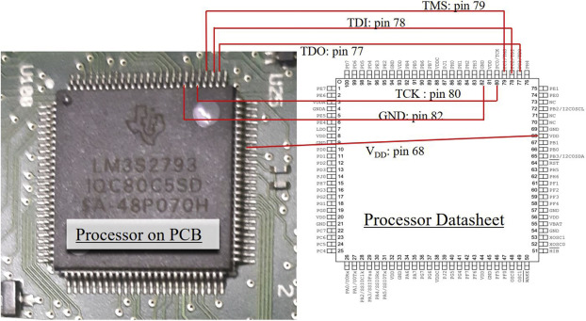

1. Diagram showing processor and datasheet pinouts [11]

We can clearly see the serial number is LM3S2793 and the logo above indicates it is from Texas Instruments. Searching for this information online will provide us with the datasheet for the processor. [12] is the user’s guide or datasheet for processor and Table 1 shows us the type of interface used, the starting pin, as well as the pins for the interface.

1. JTAG_SWD_SWO Signals (100LQFP)

| Pin Name | Pin # | Description |
| --- | --- | --- |
| SWCLK | 80 | CLK for SWD |
| SWDIO | 79 | SWDIO for SWD |
| SWO | 77 | SWO for SWD |
| TCK | 80 | JTAG CLK |
| TDI | 78 | JTAG TDI |
| TDO | 77 | JTAG TDO |

With that information we are able to use either JTAG or SWD for serial debug communication with the example device (Fig. 1).

## Boundary Scanning

Boundary scanning is used when the interface type is not known, nor the arrangement of the pins used by the interface. It can be especially useful if the manufacturer decided to remove any identifying information for the CPU which would have been used to find an accessible datasheet. This process is more involved and requires basic knowledge of a multimeter.

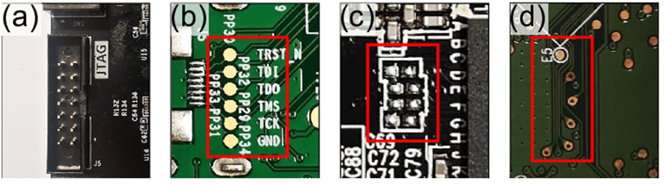

1. Photograph showing a labeled JTAG interface header

We begin by looking for any open headers on the device board. Fig. 2 shows us four different examples of JTAG headers, both labeled and unlabeled. Assuming our target device does not have labeled pads to connect our serial debugger to, we can use a device called the JTAGulator [13].

The JTAGulator is a hardware hacking tool designed by Grand Idea Studio. It helps identify On-chip debug (OCD) interfaces from test points, vias, component pads, or connectors of a target device. OCD interfaces provide control of a target device at the chip level and are often used by engineers, researchers, and hackers to extract program code or data, modify memory contents, or affect device operation. Finding available OCD interfaces can be challenging and time-consuming, especially for complex devices. The JTAGulator aims to make this process easier and faster.

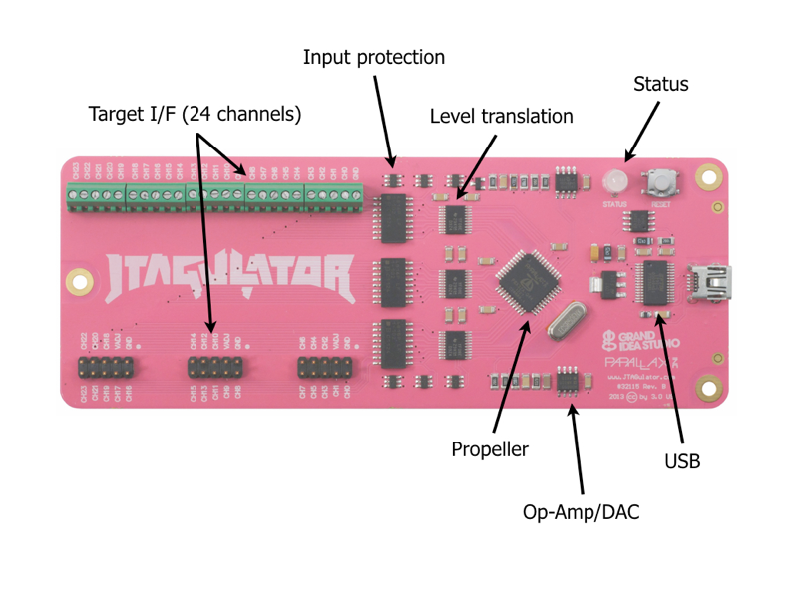

1. Diagram describing the JTAGulator I/O [13]

Using the 24 target I/F channels, we can connect the pads of the interface header from our target device board to the JTAGulator. Making sure to connect the GND to a solid ground on the target device and the optional VADJ to the voltage reference pin. Typically, the voltage reference is 3.3V or 5.5V; if this is connected, it needs to be specified.

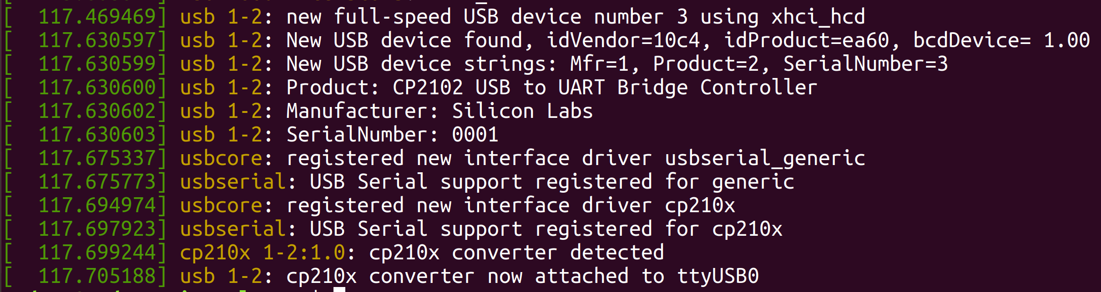

1. Screenshot of output from dmesg showing the COM port

The device will appear as a Virtual COM port and will have a device tty automatically assigned to it. For Ubuntu users, this should appear as recent output under the tool dmesg as “/dev/ttyUSB0” (Fig. 4). All communication is 115200 baud, 8 data bits, no parity, 1 stop bit. Using a terminal program such as minicom we can communicate with the JTAGulator.

If the JTAGulator successfully connects to a host, its LED will turn YELLOW and it will wait for the user to press any key from within the terminal program. The JTAGulator will then display its welcome header and command prompt. If the LED turns RED on power-up, it means the JTAGulator is in secondary operating mode and is waiting for commands from an external software tool. To return to normal JTAGulator functionality, press Ctrl-X in the terminal program.

When the JTAGulator is ready to receive commands, it will send a > to the host and the LED will turn GREEN. It will then wait for a valid command and perform it, returning any command-specific response. If an invalid command is received, the JTAGulator will respond with a "?". To set the target I/O voltage (VADJ), use the V command. This will ensure that the target receives signals within its acceptable logic levels. The voltage can be determined by measuring VCC on the target board or by checking the component's data sheet.

# Using Serial Debuggers

With the serial debug interface identified, we can use our serial debugger of choice to communicate with the target device. This can be done with either the previously documented JTAGulator or with something similar like the BusPirate or Shikra. These are devices that enable a user to interact with different types of protocols. Protocols such as JTAG, SPI, IC2, UART and GPIO via a USB interface.

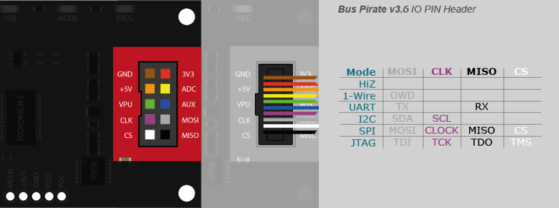

1. BusPirate wiring diagram for different serial interfaces [14]

Fig. 5 shows where each pinout of the serial interface needs to connect on a BusPirate. Once either the JTAGulator or BusPirate is connected to the target device and host, we can issue the following command using OpenOCD from the terminal [15][16]:

* openocd -f interface/buspirate.cfg -c "transport select jtag; buspirate port /dev/ttyUSB0" -f <target>
* -f <target> depends on the device, here it refers to the preferred OpenOCD config file. For the previous target device, it would have been “target/stellaris.cfg”.

Using OpenOCD with an active connection, we can scrape memory from the device, flash new firmware, or even run a remote GDB server for debugging of the chip and operating system.

# Bootloaders and Operating Systems

## Bootloaders

The bootloader used by a device is an important area to consider when auditing for vulnerabilities. Although the target device used for this research paper uses RTOS, bootloaders are still worth considering during the process. One such bootloader is “UBOOT” which replaces “GRUB”. It is built specifically with embedded devices in mind for boards based on PowerPC, ARM, MIPS and many others [17].

UBOOT is especially interesting because it has flags set during the board initialization phase that controls serial port output. Specifically, the following flags:

* CONFIG_SILENT_CONSOLE
* CONFIG_SILENT_CONSOLE_UPDATE_ON_SET
* CONFIG_SYS_DEVICE_NULLDEV

Whether or not these flags are enabled will determine if an attacker has access to memory without using more complicated methods.

## Real Time Operating System (RTOS)

A Real Time Operating System is an operating system designed to handle real-time applications. RTOSes are commonly used in applications where timing is critical. The scheduler in a RTOS is designed to provide a predictable execution pattern, which is particularly useful for embedded systems that often have real-time requirements. FreeRTOS is a class of RTOS that is designed to be small enough to run on a microcontroller and is often used in deeply embedded applications. It provides the core real-time scheduling functionality, inter-task communication, timing, and synchronization primitives. Additional functionality can be added with add-on components. A microcontroller is a small and resource constrained processor that incorporates, on a single chip, the processor itself, read only memory (ROM or Flash) to hold the program to be executed, and the RAM needed by the programs it executes. Typically, the program is executed directly from the read only memory.

Microcontrollers are often used in applications where the processor and software are not visible to the user. These applications typically have a specific and dedicated purpose, which means that the size constraints and dedicated nature of the application rarely justify the use of a full RTOS implementation. In these cases, FreeRTOS can be used to provide the core real-time scheduling functionality, inter-task communication, timing, and synchronization primitives. This makes FreeRTOS more accurately described as a real-time kernel or real-time executive. Additional functionality can be added with add-on components, such as a command console interface or networking stacks.

# Thermal Printer Audit

Thermal printers are printers that use heat to transfer ink onto paper. They work by heating up a special thermal paper with a print head, which causes the ink on the paper to be transferred onto the paper. Thermal printers are commonly used in retail environments and other settings where receipts and labels need to be printed quickly and efficiently. They are known for their fast printing speeds and their ability to print without making any noise. Unlike other types of printers, thermal printers do not require any ink or toner, which makes them more cost-effective to operate in the long run.

|  |  |
| --- | --- |
|  |  |

1. SNBC BTP-S80 Thermal Printer

The thermal printer used as the cumulative example for this research paper is the BTP-S80 from SNBC (Fig. 6) with a 25-pin serial interface, ethernet, and USB [18]. The printer is equipped with the NXP LPC4078FET208, a 32-bit ARM Cortex-M4 MCU with up to 512 kB flash and 96 kB SRAM see Fig. 7.

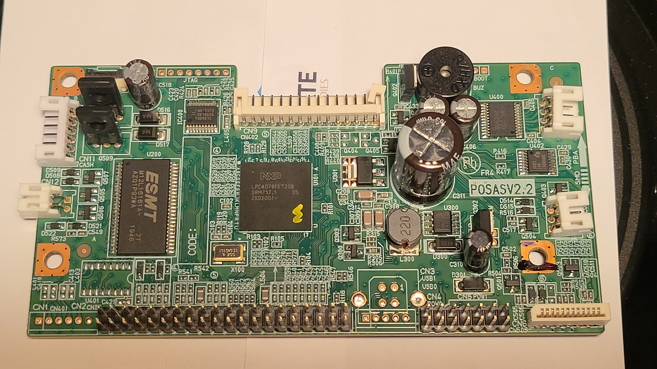

1. Board from disassembled SNBC BTP-S80

## JTAG Discovery

Following the methodology for serial debug interface discovery that was explained under Section V, we identified the processor as the NXP LPC4078FET208 and the datasheet as [19]. The JTAG pins are as follows:

1. JTAG Signals – Pin Configuration (TFBGA208)

| Pin Name | Pin # | Description |
| --- | --- | --- |
| GND | B4 | Ground |
| VDD | E2 | 3.3V supply voltage |
| VREF | G2 | Voltage Reference |
| TRST | D4 | JTAG Test Reset |
| TMS | C2 | JTAG Test Mode Select |
| TCK | D2 | JTAG Clock |
| TDI | C3 | JTAG TDI – Input |
| TDO | B1 | JTAG TDO - Output |

## JTAG Layout

Using the information from Table II, we know the interface types supported and the pin layout. Zooming further in on the board however, we can see a partially labeled interface header, Fig. 8.



1. JTAG header from the SNBC BTP-S80 board

Using the JTAGulator and a multimeter, we deduced that the JTAG layout is as follows (from left to right):

* Black – GRND – Pin B4
* Purple – TDO – Pin B1
* White – TDI – Pin C3
* Green – TMS – Pin C2
* Orange – TCK – Pin D2
* Brown – TRST – Pin D4
* Yellow – VDD – Pin E2

Refer to Fig. 9 for the color coordination of the wiring harness.

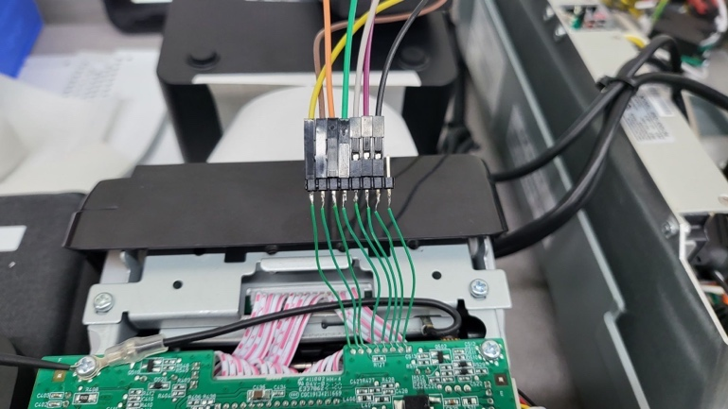

1. Wiring harness used to connect to the interface.

## Serial Connection

After connecting the JTAG interface to the NXP LPC4078FET208, we are able to see what information the serial devices can gather. We can also see that the processor is haltable, and the memory is readable; this will allow any user with serial access to dump the memory or flash new firmware onto the device while unauthorized, Fig. 10.

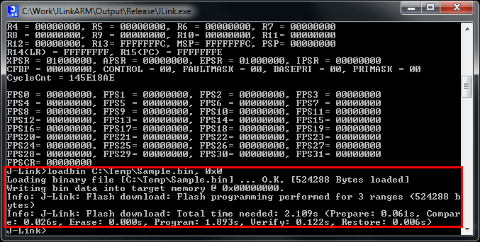

1. Dumping firmware from SNBC BTP-S80 memory

The reason we can scrape the operating system and the application data together is because of RTOS and its lightweight design choices. Since it all runs in RAM after the device has booted, we can modify or capture it during runtime. From a malicious operator’s perspective, this is useful because RTOS is opensource and there is nothing stopping them from developing a compromised version of the printer drivers to inject HID inputs back to the host.

# Conclusion

## Security Recommendations

There are several security principles that developers should follow when configuring their serial debug interfaces, including the following:

* Practice information minimization and/or hiding to increase the time and complexity of successful attacks
* Use strong and unique passwords to protect access to the serial debug interface or bootloader.
* Limit access to the serial debug interface to only authorized individuals and processes.
* Regularly update the firmware and software used by the serial debug interface to ensure that it is secure and up-to-date.
* Monitor the use of the serial debug interface and alert administrators if any unusual or suspicious activity is detected.
* Block access to I/O ports recognized by the bootloader and operating system

By following these principles, developers can help ensure that their serial debug interfaces are secure and protect their devices from potential attacks.

## Future Work

Future researchers might consider testing a wider array of accessory devices used by POS systems. And, not just different manufacturers of thermal printers, but also other devices such as scanners, touchscreens, or even expansion cards used to provide networking. Besides the additional physical devices, it would be worthwhile to build off this research and develop a RTOS image that can be deployed immediately to compatible devices for further fuzzing or HID emulation capabilities.

##### References

[1] P. Arntz, “Point-of-sale malware used to steal 167,000 credit cards,” Malwarebytes. https://www.malwarebytes.com/blog/news/2022/10/point-of-sale-malware-used-stole-the-details-of-over-167000-credit-cards (accessed Dec. 05, 2022).

[2] “Defending Against PoS RAM Scrapers: Current and Next-Generation Technologies,” p. 38, 2015.

[3] “Chip and Skim: Cloning EMV Cards with the Pre-play Attack.” https://www.ezproxy.dsu.edu:2063/document/6956556/ (accessed Dec. 05, 2022).

[4] “Security of NFC Banking Transactions: Overview on Attacks and Solutions.” https://www.ezproxy.dsu.edu:2063/document/9955600/ (accessed Dec. 05, 2022).

[5] “Spyduino: Arduino as a HID Exploiting the BadUSB Vulnerability.” https://www.ezproxy.dsu.edu:2063/document/8804730/ (accessed Dec. 05, 2022).

[6] “USBCheckIn: Preventing BadUSB attacks by forcing human-device interaction.” https://www.ezproxy.dsu.edu:2063/document/7907004/ (accessed Dec. 05, 2022).

[7] “1149.1-2013 - IEEE Standard for Test Access Port and Boundary-Scan Architecture.” https://www.ezproxy.dsu.edu:2063/document/6515989/ (accessed Dec. 05, 2022).

[8] “Use of JTAG boundary-scan for testing electronic circuit boards and systems.” https://www.ezproxy.dsu.edu:2063/document/4662576/ (accessed Dec. 05, 2022).

[9] “Design and Implementation of High-Speed Universal Asynchronous Receiver and Transmitter (UART).” https://www.ezproxy.dsu.edu:2063/document/9070856/ (accessed Dec. 05, 2022).

[10] “Single Wire Debug Interface.” https://www.ezproxy.dsu.edu:2063/document/9184647/ (accessed Dec. 05, 2022).

[11] M. H. Rais, R. A. Awad, J. Lopez, and I. Ahmed, “JTAG-based PLC memory acquisition framework for industrial control systems,” Forensic Sci. Int. Digit. Investig., vol. 37, p. 301196, Jul. 2021, doi: 10.1016/j.fsidi.2021.301196.

[12] “LM3S2793-IQC80-C5 Datasheet.” https://pdf1.alldatasheet.com/datasheet-pdf/view/462307/TI1/LM3S2793-IQC80-C5.html (accessed Dec. 06, 2022).

[13] “JTAGulator.” Grand Idea Studio, Dec. 05, 2022. Accessed: Dec. 06, 2022. [Online]. Available: https://github.com/grandideastudio/jtagulator

[14] “Bus Pirate v3.6a Hookup Guide - SparkFun Learn.” https://learn.sparkfun.com/tutorials/bus-pirate-v36a-hookup-guide/all (accessed Dec. 06, 2022).

[15] “Top (OpenOCD User’s Guide).” https://openocd.org/doc/html/index.html (accessed Dec. 06, 2022).

[16] “openocd(1) - Linux man page.” https://linux.die.net/man/1/openocd (accessed Dec. 06, 2022).

[17] “Implementation of an embedded system of UART and LED using UBOOT & Linux.” https://www.ezproxy.dsu.edu:2063/document/7225464/ (accessed Dec. 06, 2022).

[18] “SNBC BTP-S80 Thermal Printer - Black Cabinet (Bluetooth),” CRS Inc. https://www.crs-usa.com/products/printers/thermal-printers/snbc-btp-s80-thermal-printer-black-(bluetooth) (accessed Dec. 06, 2022).

[19] “LPC4088FET208,551 NXP Semiconductors | Mouser,” Mouser Electronics. https://www.mouser.com/ProductDetail/771-LPC4088FET208551 (accessed Dec. 06, 2022).